Drift forces and QTF Implementation of NEMOH Deployment Guide

Revision History
Author | Revision Number | Date
yedtoss | 1.0 | 17/12/2014
Deployment Instructions 3
1. Organization of Submission 3
2. Application Setup 3
Linux 3
Windows 3
MAC OS X 3
Variables 4
3. Configuration 4
4. Implementation details 6
5. Deployment Instructions 6
5.1. Generic Instructions 6
5.2. Linux Instructions with Ubuntu commands 7
5.3. Windows Instructions 8
5.4. MAC OS X Instructions 10
6. Starting 11
7. Verification 12
8. Resource Contact List 14

Deployment Instructions

Organization of Submission
Nemoh/ Contains the modified source of Nemoh Fortran software
docs/ Contains this deployment guide
NemohPython/ Contains the modified Nemoh Python code
README.txt note about testing previous old Fortran code

Application Setup

Linux
- GCC with GFortran >= 4.8
- BLAS
- LAPACK
- OpenMP provided by GCC
- HDF5 >=1.8.11 http://www.hdfgroup.org/HDF5/ Optionally provided by Anaconda
- HDFView http://www.hdfgroup.org/products/java/release/download.html
- Python 2.7 Optionally provided by Anaconda
- H5py >= 2.3.1 Optionally provided by Anaconda
- Numpy Optionally provided by Anaconda
- Cmake >= 2.8 http://www.cmake.org/cmake/resources/software.html
- Anaconda (with Python 2.7) >= 2.1.0 http://continuum.io/downloads

Windows
- MinGW 4.8.1 http://sourceforge.net/projects/MinGWbuilds/files/host-windows/releases/4.8.1/
- BLAS http://icl.cs.utk.edu/lapack-for-windows/lapack/#libraries
- LAPACK http://icl.cs.utk.edu/lapack-for-windows/lapack/#libraries
- OpenMP provided by MinGW
- HDF5 >=1.8.11 http://www.hdfgroup.org/HDF5/ Optionally provided by Anaconda
- HDFView http://www.hdfgroup.org/products/java/release/download.html
- Python 2.7 Optionally provided by Anaconda
- H5py >= 2.3.1 Optionally provided by Anaconda
- Numpy Optionally provided by Anaconda
- CMake >= 4.8 http://www.cmake.org/cmake/resources/software.html
- Anaconda (with Python 2.7) >= 2.1.0 http://continuum.io/downloads

MAC OS X
- Brew http://brew.sh/
- GCC >= 4.8 installed by brew
- XCode Command Line Tools installed by brew
- BLAS provided by XCode commands
- LAPACK Provided by XCode commands
- OpenMP provided by GCC
- HDF5 >=1.8.11 http://www.hdfgroup.org/HDF5/ Optionally provided by Anaconda
- HDFView http://www.hdfgroup.org/products/java/release/download.html
- Python 2.7 Optionally provided by Anaconda
- H5py >= 2.3.1 Optionally provided by Anaconda
- Numpy Optionally provided by Anaconda
- Cmake >= 4.8 installed by brew
- Anaconda (with Python 2.7) >= 2.1.0 http://continuum.io/downloads

Variables

Let's call:
$NEMOH_FORTRAN the directory Nemoh/ in the root of the submission directory
$NEMOH_PYTHON the directory NemohPython/
$FORTRAN_BUILD the build directory for the FORTRAN version of Nemoh
$MINGW_ROOT the directory where MINGW will be installed

Configuration

The Python code can be configured using the file $NEMOH_PYTHON/nemoh/settings.py

Property | Definition | Example
GREEN_TABULATION_NUMX | Number of points in x direction of tabulated data | 500
GREEN_TABULATION_NUMZ | Number of points in z direction of tabulated data | 60
GREEN_TABULATION_SIMPSON_NPOINTS | Number of sub intervals used to approximate the green function integral using simpson rule | 551
HDF5_FILE | The path to the hdf5 file where to save and load the results and input. Required | 'db.hdf5'  No need to change
NEMOH_CALCULATIONS_FILE | The old nemoh calculation file.  Not required but it is needed to automatically convert the old Nemoh.cal file to hdf5 storage | 'Nemoh.cal'  No need to change but then make sure you have the nemoh calculation file Nemoh.cal in your working directory.  Also make sure the path to the mesh file references in Nemoh.cal exists. For example if in the Nemoh.cal file you have 'Cylinder.dat', then you should have the Cylinder.dat file in your current directory
NEMOH_INPUT_FILE | Same as above but applied to the nemoh input file | 'input.txt'  No need to change but then make sure you have the nemoh input file input.txt in your working directory
NEMOH_INT | Represents the integer type to use when performing computations.  It should be a valid numpy integer type.  See http://docs.scipy.org/doc/numpy/reference/arrays.scalars.html#arrays-scalars-built-in  for possible values | 'i'
NEMOH_FLOAT | Represents the float type to use when performing computations.  It should be a valid numpy float type.  See http://docs.scipy.org/doc/numpy/reference/arrays.scalars.html#arrays-scalars-built-in  for possible values | 'f'
NEMOH_COMPLEX | Represents the complex type to use when performing computations.  It should be a valid numpy complex type.  See http://docs.scipy.org/doc/numpy/reference/arrays.scalars.html#arrays-scalars-built-in  for possible values | 'F'
MESH_TEC_FILE | The path to the file where to save the mesh tec file | No need to change. The default value is fine.
FK_FORCE_TEC_FILE | The path to the froudkrylov force data in tec format | No need to change. The default value is fine.
RADIATION_COEFFICIENTS_TEC_FILE | The path to the file where to save the added mass and damping forces for the radiation problems  in tec format. | No need to change. The default value is fine.
DIFFRACTION_FORCE_TEC_FILE | The path to the file where to save the diffraction force for the diffraction problems  in tec format. | No need to change. The default value is fine.
EXCITATION_FORCE_TEC_FILE | The path to the file where to save the excitation force for the diffraction problems  in tec format. | No need to change. The default value is fine.
IRF_TEC_FILE | The path to the file where to save the IRF tec file | No need to change. The default value is fine.
WAVE_FIELD_TEC_FILE | The path to the file where to save the wave field tec file | No need to change. The default value is fine.

Implementation details

References

R1 Computation of Higher-Order Hydrodynamic Forces on Ships and Offshore Structures in Waves http://dspace.mit.edu/bitstream/handle/1721.1/79979/42664020.pdf?sequence=1

R2 Wamit User Manual http://www.wamit.com/manualupdate/V70_manual.pdf

The drift forces and yaw moment have been implemented in

"$NEMOH_FORTRAN/Solver/Core/COMPUTE_MEAN_DRIFT_FORCES_FIN.f90", "$NEMOH_FORTRAN/Solver/Core/COMPUTE_MEAN_DRIFT_FORCES_INF.f90",
"$NEMOH_FORTRAN/Solver/Core/COMPUTE_YAW_MOMENT_FIN.f90" "$NEMOH_FORTRAN/Solver/Core/COMPUTE_YAW_MOMENT_INF.f90"

The main formula for the computation is R2 equation 15.58 and 15.59

After transformation and after expressing the equations in terms of the Kochin functions we have the equations 4.1, 4.2 for the mean drift forces in infinite depth (reference R1) and 4.6 for the yaw moment in infinite depth.

For finite depth we have 4.7 to 4.9 in reference R1

Deployment Instructions

Generic Instructions

    - Install Fortran and C/C++ compilers which support OpenMP (Currently GCC and ifort are supported)
    - Install Python 2.7
    - Install pip
    - Install CMake version greater or equal to 2.8
    - Install BLAS and LAPACK and make sure there are in the library search paths
    - Install HDF5 libraries version greater or equal to 1.8.11 and make sure they are in the library search path

    - Compile the Fortran version of Nemoh Solver:
      - Create a build directory $FORTRAN_BUILD different from $NEMOH_FORTRAN
      - Go to $FORTRAN_BUILD folder.
      - Delete the file CMakeCache.txt and the directory CMakeFiles if it exists
      - Run the command cmake $NEMOH_FORTRAN
      - Run make. The Nemoh library will be created

    - Compile the Nemoh Python against the Nemoh Fortran
      - Go to $NEMOH_PYTHON
      - Install the Python module prerequisites pip install -r requirements.txt
      - Make sure the $FORTRAN_BUILD is in the library search paths for compilation and for linking
      - Run python setup.py build_ext --inplace

Linux Instructions with Ubuntu commands
(If you are not using Ubuntu, you should be able to use your distribution package manager to install equivalent commands)

    - Install GFortran and GCC by running: sudo apt-get install build-essential gfortran gcc

    - Install cmake by running sudo apt-get install cmake

    - Install Blas and Lapack and make sure there are in the library search paths by running
sudo apt-get install liblapack-dev libblas-dev

    - Install Python 2.7, hdf5 libraries, and the nemoh Python module requirements. To do so, we just need to install Anaconda:
      - Download Anaconda >= 2.1.0 from http://continuum.io/downloads .
For linux 64 bits the direct link is (with no space) http://09c8d0b2229f813c1b93-c95ac804525aac4b6dba79b00b39d1d3.r79.cf1.rackcdn.com/Anaconda-2.1.0-Linux-x86_64.sh
      - Install Anaconda by running bash Anaconda-2.1.0-Linux-x86_64.sh
      - When prompted, accept to add it's path to your ~/.bashrc.
      - Make sure the Python version you are using is the one from Anaconda by logout then login or by running source ~/.bashrc
      - If successful, when you run python --version you should see something like Python 2.7.8 :: Anaconda 2.1.0 (64-bit)

    - Compile the Nemoh Fortran
      - Create a build directory $FORTRAN_BUILD different from $NEMOH_FORTRAN
      - Go to $FORTRAN_BUILD folder by running cd $FORTRAN_BUILD.
      - Delete the file CMakeCache.txt and the directory CMakeFiles if it exists by running rm -rf CMakeCache.txt CMakeFiles/
      - Run cmake -DCMAKE_Fortran_COMPILER="gfortran" $NEMOH_FORTRAN to generate the Makefiles
      - Run make to build the library
      - The library libnemoh.so will be created

    - Compile the nemoh Python against the nemoh Fortran
      - Go to $NEMOH_PYTHON/nemoh
      - Make sure the $FORTRAN_BUILD is in the library search paths for compilation and for linking by running:
export LD_LIBRARY_PATH=$FORTRAN_BUILD
export LDFLAGS="-L$FORTRAN_BUILD"
      - Run python setup.py build_ext --inplace to build the Python module in place

Windows Instructions

    - Install MinGW 4.8.1
      - You should install posix threads MinGW from http://sourceforge.net/projects/MinGWbuilds/files/host-windows/releases

The 64 bits is located at http://sourceforge.net/projects/MinGWbuilds/files/host-windows/releases/4.8.1/64-bit/threads-posix/sjlj/x64-4.8.1-release-posix-sjlj-rev5.7z/download

The 32 bits is located at http://sourceforge.net/projects/MinGWbuilds/files/host-windows/releases/4.8.1/32-bit/threads-posix/sjlj/x32-4.8.1-release-posix-sjlj-rev5.7z/download

      - Download the binaries for your platform and extract it somewhere. By default the 64 bits get extracted in a directory named "MinGW64". Let's call this directory $MINGW_ROOT

      - Now add the full path to the folder $MINGW_ROOT\bin and $MINGW_ROOT\lib to your Path. Make sure those directories are at the left most (the beginning) of the Path. See Setting Path on Windows sub section for more information

    - Install CMake 2.8
      - Download and install CMake from http://www.cmake.org/files/v2.8/cmake-2.8.12.2-win32-x86.exe
      - Choose to add Cmake to the path for all users. By default CMake doesn't put the path at the beginning.
So, you need to make sure the CMake path is at the beginning of your path. It is by default " C:\Program Files (x86)\CMake 2.8\bin". See Setting Path on Windows sub section for more information

    - Install Lapack and Blas
Download and install lapack and blas from http://icl.cs.utk.edu/lapack-for-windows/lapack/#libraries Choose the dll libraries for MinGW

The 64 bits blas is http://icl.cs.utk.edu/lapack-for-windows/libraries/VisualStudio/3.5.0/Dynamic-MINGW/Win64/libblas.dll
And the 64 bits lapack is
http://icl.cs.utk.edu/lapack-for-windows/libraries/VisualStudio/3.5.0/Dynamic-MINGW/Win64/liblapack.dll

      - Copy them to $MINGW_ROOT\lib (the lib directory inside MinGW installation root)

    - Install Anaconda >= 2.1.0
      - Download and install Anaconda Windows version greater than or equal to 2.1.0 from http://continuum.io/downloads . The 64 bits Windows version is located at
http://09c8d0b2229f813c1b93-c95ac804525aac4b6dba79b00b39d1d3.r79.cf1.rackcdn.com/Anaconda-2.1.0-Windows-x86_64.exe

      - When installing accept adding anaconda to the path and using it's Python version as the default Python.
By default Anaconda would not put it's path to the beginning of the Windows Path.

You need to move the anaconda paths to the beginning of the Path list.
See Setting Path on Windows sub section for more information

For me the paths were C:\Users\yedtoss\Anaconda (the most important) and C:\Users\yedtoss\Anaconda\Scripts. You should replace C:\Users\yedtoss\Anaconda by the location where you install Anaconda

    - Compile the Nemoh Fortran
      - Start Powershell (Or windows cmd if you prefer it)
Make sure that all paths were correctly set. If not then you should close Powershell/Cmd, set the path and reopen it. Basically run python --version, cmake --version, gfortran --version and verify that they come from the one you just installed

      - Create a build directory $FORTRAN_BUILD different from $NEMOH_FORTRAN
      - Go to $FORTRAN_BUILD folder.
      - Delete the file CMakeCache.txt and the directory CMakeFiles if it exists or better make sure $FORTRAN_BUILD is empty
      - Run cmake -DCMAKE_Fortran_COMPILER="gfortran" "$NEMOH_FORTRAN" -G "MinGW Makefiles"

Please note the "" surrounding $NEMOH_FORTRAN. You need it even if the directory does not contain space. Make sure "$NEMOH_FORTRAN" is a full path to avoid any cmake bug

      - Run mingw32-make clean followed by mingw32-make and you will get libnemoh.dll and libnemoh.dll.a
      - Copy both generated files to $MINGW_ROOT\lib

    - Compile the nemoh Python against the nemoh Fortran
      - Go to $NEMOH_PYTHON\nemoh
      - Run python setup.py build_ext --inplace

    - Setting Path on Windows
You need to go to Computer → Right click and choose Properties → Advanced System Settings → Advanced Tabs → Environment Variables → Look for path.

A screenshot

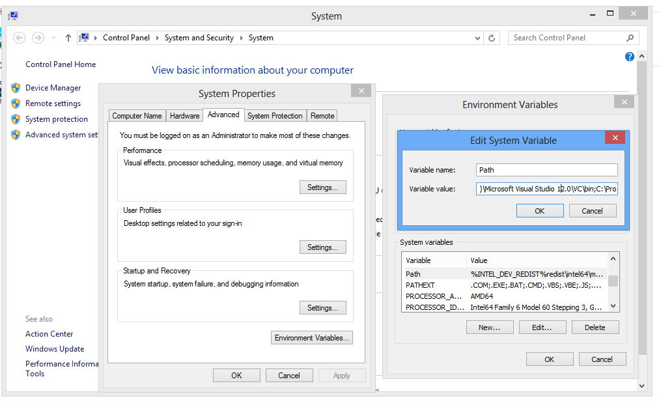

Note that when setting the path, you need to separate the different directories by ; Also make sure your new directory is not at the end of the list but at the beginning because Windows reads the environment variables from left to right.

MAC OS X Instructions

We will use homebrew to install most software

    - Install brew: ruby -e "$(curl -fsSL https://raw.githubusercontent.com/Homebrew/install/master/install)"
(If you did not have XCode Command Line Tools, it will request it, install it and when done
press enter on the terminal)

    - Run brew doctor
    - Install GCC and gfortran brew install gcc You can ignore any warning about multilib. It won't affect us
    - Install cmake brew install cmake

    - Download and Install anaconda from http://continuum.io/downloads
You can get the 64 bits version from http://09c8d0b2229f813c1b93-c95ac804525aac4b6dba79b00b39d1d3.r79.cf1.rackcdn.com/Anaconda-2.1.0-MacOSX-x86_64.pkg
We will export anaconda bin to the Path before compiling and using the nemoh Python module

    - Compile the Nemoh Fortran
      - Create a build directory $FORTRAN_BUILD different from $NEMOH_FORTRAN
      - Go to $FORTRAN_BUILD folder cd $FORTRAN_BUILD .
      - Delete the file CMakeCache.txt and the directory CMakeFiles if it exists rm -rf CMakeCache.txt CMakeFiles/
      - Run cmake -DCMAKE_Fortran_COMPILER="gfortran" $NEMOH_FORTRAN
      - Generate nemoh Fortran library by running make
The library libnemoh.dylib will be created
(If you get a warning about cmake policy ignore it)

    - Compile the nemoh Python against the nemoh Fortran
      - Go to $NEMOH_PYTHON/nemoh
      - Make sure you are using Python from Anaconda
By running export PATH=/Users/tcs/anaconda/bin:$PATH
Replace /Users/tcs/anaconda/bin according to the location where anaconda was installed
      - Make sure the $FORTRAN_BUILD is in the library search paths for compilation and for linking by running
export LD_LIBRARY_PATH=$FORTRAN_BUILD
export LDFLAGS="-L$FORTRAN_BUILD"
      - Run python setup.py build_ext --inplace

Note that in the above process we did not explicitly install lapack or blas libraries. This is because it is implicitly installed with brew (XCode Command Line Tools). If for some reason you receive an error when linking against lapack or blas you can install a custom version by running brew install https://raw.githubusercontent.com/Homebrew/homebrew-dupes/master/lapack.rb

Also note that the Intel Fortran Compiler (ifort) is fully supported on all three platforms. It comes bundled with lapack and blas so if you choose it, you won't need them.

Installing VMTK (Optional, you can skip)

VMTK is used by $NEMOH_PYTHON/nemoh/export_tec.py to export the generated .tec files to other format. To install it for Mac, Windows or Linux follow instructions at http://www.vmtk.org/documentation/installation.html
Note that unless you are using the .egg for Anaconda (Windows only), you should not use it with the Python from Anaconda. More specifically, on Linux and Mac you have to use it with the built-in Python when installing or using it.

Starting
You need to setup all environment variables as described in the deployment instructions.
You should also configure the application as described in the configuration section.
Enter the directory $NEMOH_PYTHON/nemoh/
Run python preprocessor.py to run the preprocessor
Then run the solver with python solver.py
Finally run the post processor with python postprocessor.py

Verification
Setup your environment using the deployment instructions.
Then run the tools by following the Starting section.

By default, the cylinder example has been configured. You can run other example by modifying the configuration. You can find additional cases files in $NEMOH_FORTRAN/Verification folder
The hdf5 file and db.hdf5 will be generated.

You can visualize it with HDFView from http://www.hdfgroup.org/products/java/release/download.html
It has a version for Windows, MAC and Linux.

For example, to install the Ubuntu 64 bits:
- Download http://www.hdfgroup.org/ftp/HDF5/hdf-java/current/bin/HDFView-2.10.1-centos5-static64.tar.gz

- Extract it to /tmp so that you have /tmp/HDFView-2.10.1-Linux, then locate the file hdfview.sh inside it. It should be located at
/tmp/HDFView-2.10.1-Linux/HDF_Group/HDFView/2.10.1/bin/hdfview.sh
- Open the file hdfview.sh and set INSTALLDIR to ..
- Enter the bin directory (/tmp/HDFView-2.10.1-Linux/HDF_Group/HDFView/2.10.1/bin)
- Make sure you have java from Oracle, JRE is enough. You can use JRE 6 or JRE 7
- Run bash hdfview.sh
Then open the hdf5 file (Click File → Open)

Enter the directory $NEMOH_PYTHON/nemoh/
Run python preprocessor.py to run the preprocessor
Then run the solver with python solver.py
Finally run the post processor with python postprocessor.py

Now Open db.hdf5 with hdfview. You should see the following screenshot for the drift forces.

You can see it is a 3D array F(287x181x2). 287 is for the number of problems.
181 is for the number of wave incident directions. 2 indicates the x and y component of the drift forces. In short F(1,1,1) contains the x component of the drift force for the first problem and the first wave incident angle whereas F(1,1,2) contains the y component.

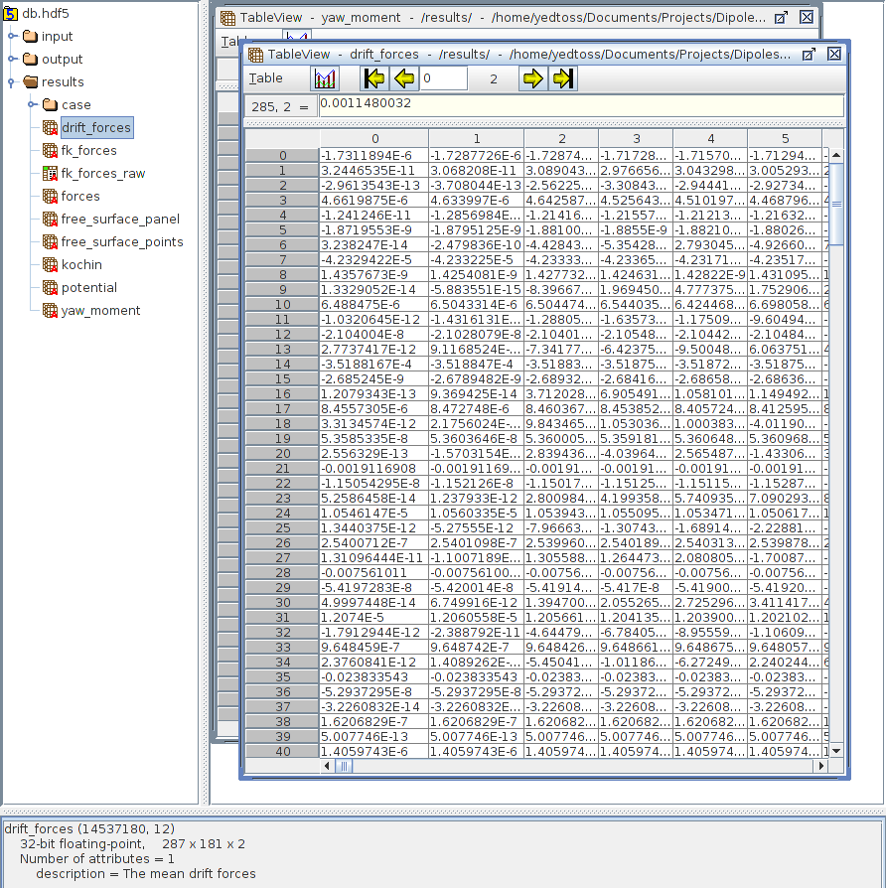

For the yaw moment you should see the following screenshot

You can see it is a 2D array F(287x181). 287 is for the number of problems.
281 is for the number of wave incident directions. In short F(1,1) contains the z component of the yaw moment for the first problem and the first wave incident angle.

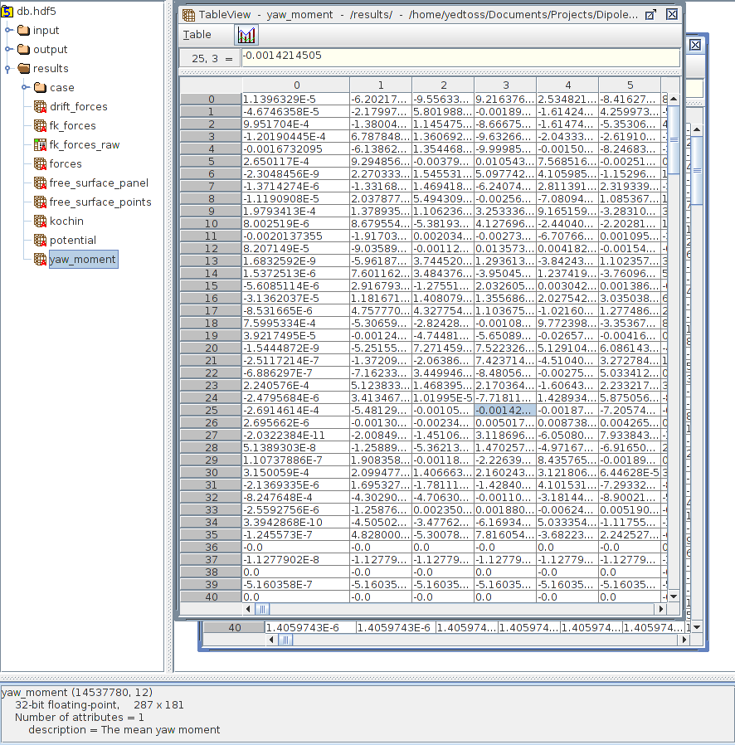

Resource Contact List

Name | Resource Email
yedtoss

